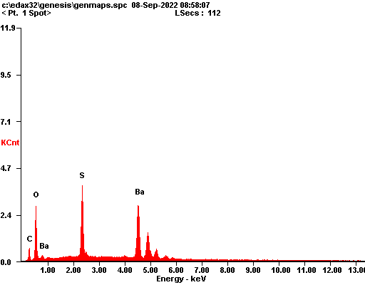

|  |  |  |
| --- | --- | --- |
| ***Element*** | ***Wt%*** | ***At%*** |
| ***CK*** | 06.17 | 24.90 |
| ***OK*** | 10.15 | 30.77 |
| ***SK*** | 12.75 | 19.28 |
| ***BaL*** | 70.93 | 25.04 |
| ***Matrix*** | Correction | ZAF |

